Authors Response (MDPI Actuators)
Adaptive Vision-Based Gait Environment Classification for Soft Ankle Exoskeleton
by Brian Byunghyun Kang, Gayoung Yang, Jeong Heo

The author is grateful for the Editor’s and the Reviewers’ constructive comments regarding the manuscript. I have done my best to answer all the questions raised by the Reviewers and have revised the manuscript as per his/her advices. The manuscript has been carefully reviewed and the author tried to include all the comments and concerns as much as possible. I have quoted below the Reviewer’s comments in order, and put my answers after each comment. I sincerely hope that the revised manuscript will be a worthy candidate for publication.* The main modifications are colored in red in the revised manuscript, shown after the Authors Response.
* All the numbers of the figures, equations, references and tables in this response letter were written according to the numbers in the revised manuscript.

Reviewer: 1
Comments to the Authors:
The study focuses on developing a vision-based intelligent gait environment detection algorithm for a lightweight ankle exosuit aimed at enhancing the gait stability and safety of stroke patients, particularly during challenging tasks like stair negotiation. The novel system integrates detailed environment classification with spatio-temporal feature extraction to adapt to dynamic gait environments effectively.
To achieve this, the system utilizes the YOLO (You Only Look Once) model for real-time environment segmentation and the LSTM (Long Short-Term Memory) network to improve accuracy during transitions by analyzing temporal patterns in the gait data. The YOLO-LSTM approach demonstrated significant improvements in recognizing and responding to environmental changes, achieving high accuracy and minimizing misclassifications.
Experimental evaluations involving kinematic and muscle activation analysis showed that the integration of the vision-based algorithm significantly improved the exosuit's functionality. The ankle exosuit increased dorsiflexion angles during level walking, which helps mitigate foot drop symptoms and enhance foot clearance. During stair ascent, the exosuit reduced muscle activation in key muscles, thereby reducing the metabolic cost and muscle fatigue for stroke patients. However, during stair descent, the system showed similar muscle activation levels irrespective of the exosuit's powered state, likely due to natural gravitational forces.
Overall, the study concludes that combining advanced spatio-temporal feature extraction with vision-based environment classification enhances the adaptability and effectiveness of gait assistance exoskeletons in complex environments, providing better support and safety for stroke patients. Future work will focus on testing the exosuit in more diverse real-world scenarios and with a broader range of subjects to validate and generalize the findings further.
The paper is well written and interesting, I accept it with Major Revision
1) I suggest the authors cite 10.3389/frobt.2024.1341580 to compare the results obtained in their work with respect to the literature results collected in this review in the "Locomotion Classification" section.
Response: We appreciate the constructive suggestion to cite the paper (10.3389/frobt.2024.1341580) for comparison in the "Locomotion Classification" section. However, we found that the studies referenced in this section focus on different objectives, such as gait phase detection, or utilize different input information, such as sEMG signals, which makes precise comparison challenging. Instead, we have compared our results with prior studies that also employ camera sensors for locomotion environment classification, as they are more aligned with the objectives of our research. We have included the comparison of the environment classification accuracy in the “6. Discussion” section. We appreciate your understanding.
Furthermore, we acknowledge that the recommended paper provides a comprehensive overview of AI-based methodologies applied to exoskeleton-assisted rehabilitation. While its focus does not directly align with the specific objectives of our locomotion classification system, it offers valuable insights into the broader context of AI in rehabilitation robotics. Therefore, we have cited this research paper in the “1. Introduction” section to help frame our contribution within this wider AI-driven landscape, particularly highlighting the importance of integrating AI in various facets of lower-limb rehabilitation.

Action: The modifications made in the new manuscript are listed below:

- 1. Introduction (Paragraph 5)
“To enhance the overall performance of the vision system, the deep learning-based methodologies can be employed. Recent advancements in deep learning model have significantly influenced diverse fields, including robotics such as robot control and intention detection, leading to enhanced performance and novel methodologies [*].”
* Coser, O.; Tamantini, C.; Soda, P.; Zollo, L. AI-based methodologies for exoskeleton-assisted rehabilitation of the lower limb: a review. Frontiers in Robotics and AI 2024, 11, 1341580

- 6. Discussion (Paragraph 2)
“… In comparison to previous studies, which reported accuracies 97.5%, 85.5% and 91.1% for various terrains such as level ground, stair incline, and decline environments, this research demonstrates improved performance with accuracies of 98.4%, 97.2%, and 95.0% for each condition [*]. This suggests that our method achieves high accuracy across various terrains, thereby improving the effectiveness in real-world applications. The advancements observed in the results may be attributed to the integration of more sophisticated environmental recognition algorithm and the utilization of advanced deep learning techniques.”
*Reference [36] in the manuscript

2) I would suggest improving the abstract by explaining the use of YOLOv8 +LSTM and the accuracy obtain so that is someone read only the abstract it catch the important information
Response: Thank you for your valuable feedback. In response to the reviewer’s suggestions, we have revised abstract to include details about YOLOv8 and LSTM for gait environment detection, as well as the classification accuracy obtained. Specifically, we have clarified that the proposed system utilizes YOLOv8 for real-time object detection and LSTM for spatio-temporal feature analysis, and we have added the classification accuracy to ensure that readers are informed about the performance of our method when only reviewing the abstract. We are grateful for the constructive suggestions, which have helped us enhance the clarity and quality of the manuscript
Action: The modification has been made in the manuscript as follows:

- Abstract
“The proposed system employs YOLOv8 for real-time environment classification, combined with a long short-term memory (LSTM) network for spatio-temporal feature extraction, enabling precise detection of environmental transitions.
…
The algorithm achieved an overall accuracy of over 95% per class, significantly enhancing the exosuit's ability to detect environmental changes, thereby improving its responsiveness to various conditions.
Notably, the exosuit increased ankle dorsiflexion angles and reduced muscle activation during stair ascent, enhancing foot clearance.
The results of this study indicated that advanced spatio-temporal feature analysis and environment classification improve the exoskeleton's gait assistance, improving adaptability in complex environments for stroke patients.”

Additional revisions:
In addition to addressing the reviewers' comments, we have made several further modifications to enhance the clarity and overall quality of the manuscript. These changes, although not specifically highlighted by the reviewers, include the correction of typographical errors, spacing issues, and grammatical mistakes; the revision of the EMG signal graphs for the TA and MG muscles; adjustments to the formatting of subsection titles; and improvements in the visibility of figure labels, legends, and titles. We believe these revisions contribute positively to the manuscript and provide a clearer understanding of our findings.

1) We acknowledge that there are typographical errors, spacing issues and grammatical mistakes present in the manuscript.

Action: All noted typographical errors, spacing issues and grammatical errors have been corrected, and we have ensured that the manuscript now adheres to the required standards of accuracy.

“The label value of the walking environment, denoted as vision data k, defined as Equation(1), is subsequently transmitted to Simulink via user datagram protocol (UDP) communication.”
“The MotorInputData processed according to Equation (3) informs motor input parameters, derived from the shank angular velocity w_s and thigh angular velocity w_t, outlined in Equation (2).”
“YOLO algorithm is an object detection framework widely utilized in various computer vision fields [*].”
“LSTM is a recurrent neural network (RNN) designed to train long-term dependencies in sequential data and demonstrates superior performance by overcoming the vanishing and exploding gradient problems inherent in traditional RNN [*]”
“Surface electromyography (sEMG) sensors (LAXTHA Inc., South Korea). were employed to measure muscle activation during gait in each experimental condition.”
“Figure 5. (d) Integrated vision system-based environment classification results over time”
“The results of TA muscle activation for each gait environment are presented in Figure 7.”
“Furthermore, similar ankle angles are observed whether the exosuit is in an unpowered or powered state.”
*Reference [46, 48] in the manuscript

2) During the review of the manuscript, we identified an error where the prediction values and true value data were reversed in the YOLO-LSTM graph and evaluation metrics. We sincerely regret this oversight that occurred during the processing of the original graphs. To prevent such errors in the future, we meticulously re-evaluated the data within the manuscript to ensure accuracy.

Action: We recalculated and updated the precision, recall, F1 score, and accuracy values in Table 2. Additionally, we have revised the confusion matrix and environment classification results over time in Figures 5(b) and (d). However, we would like to emphasize that the conclusion regarding improved performance compared to the YOLO system remains unchanged, with only the values in the graph being adjusted.

- Table 2. Environment Classification Performance
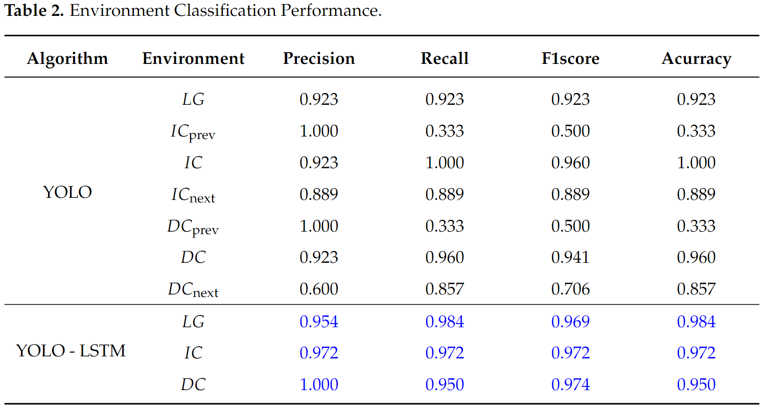

- Figure 5. Evaluation metrics for real-time gait environment classification vision system
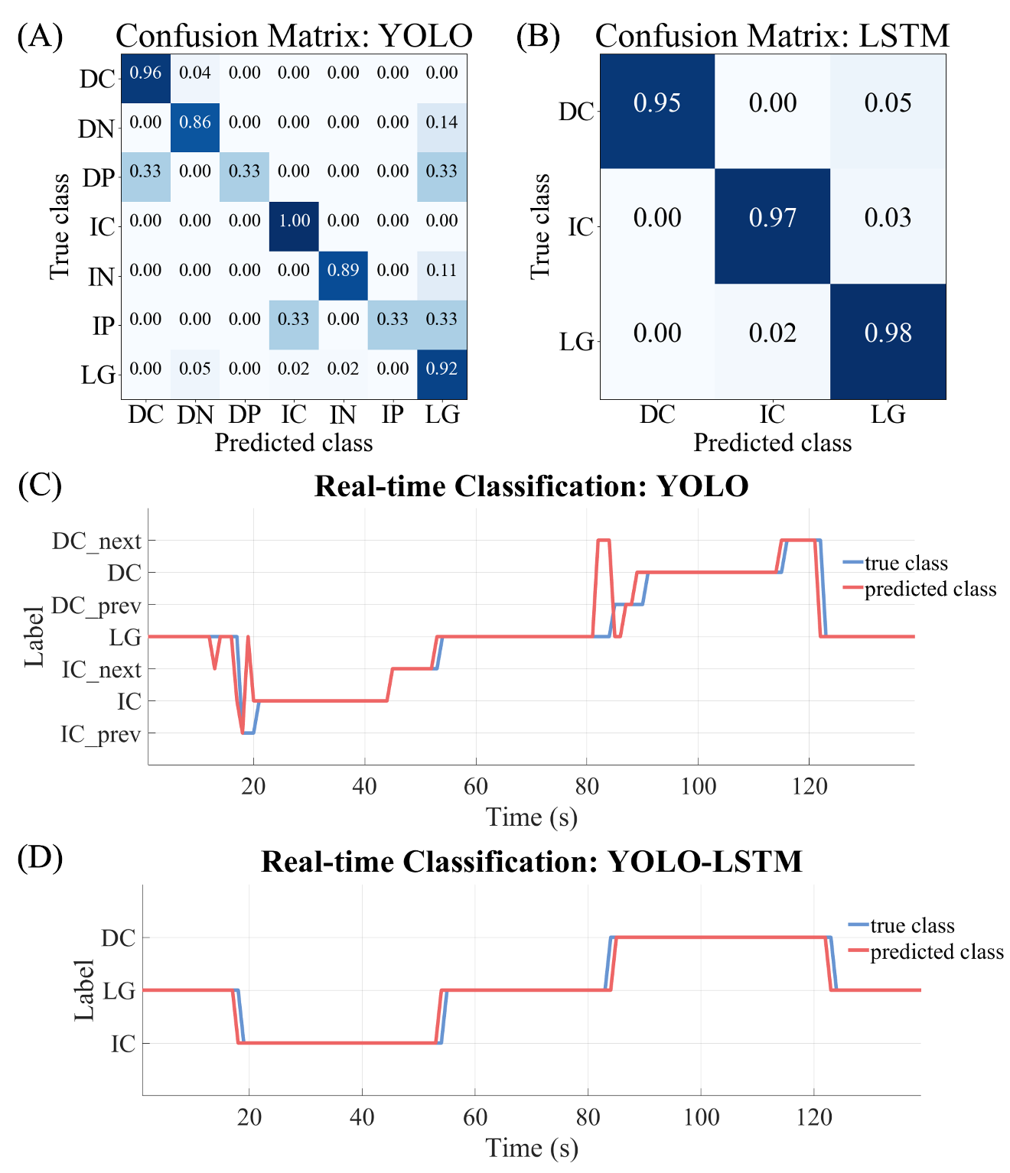

3) We have identified that the graphs representing the EMG signals for the TA and MG muscles were recorded in reverse within the corresponding graph. Furthermore, we noticed discrepancies in the p-values and asterisks between the no exo and exo off conditions, as well as between the exo off and exo on conditions for the TA muscle during the stair decline environment.

Action: In response, we undertook a thorough review of the graph positions and indices, resulting in the necessary corrections to ensure accurate representation. We have taken care to rectify the asterisks to align correctly with the calculated p-values. We appreciate your understanding as we strive to enhance the quality of our work.

- Figure 7. TA muscle activation across the gait cycle for each gait environment.
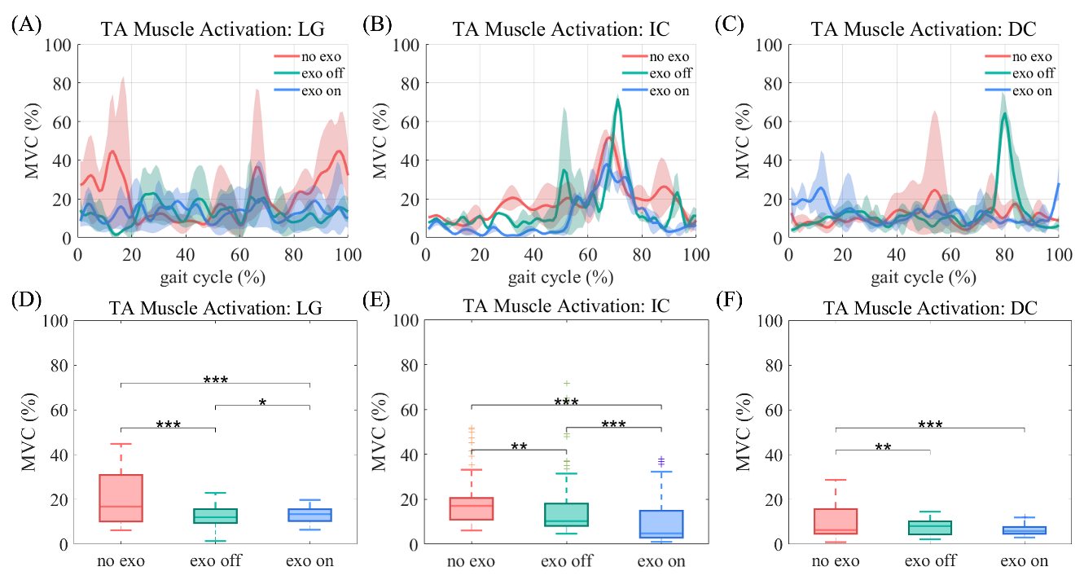

- Figure 8. MG muscle activation across the gait cycle for each gait condition.
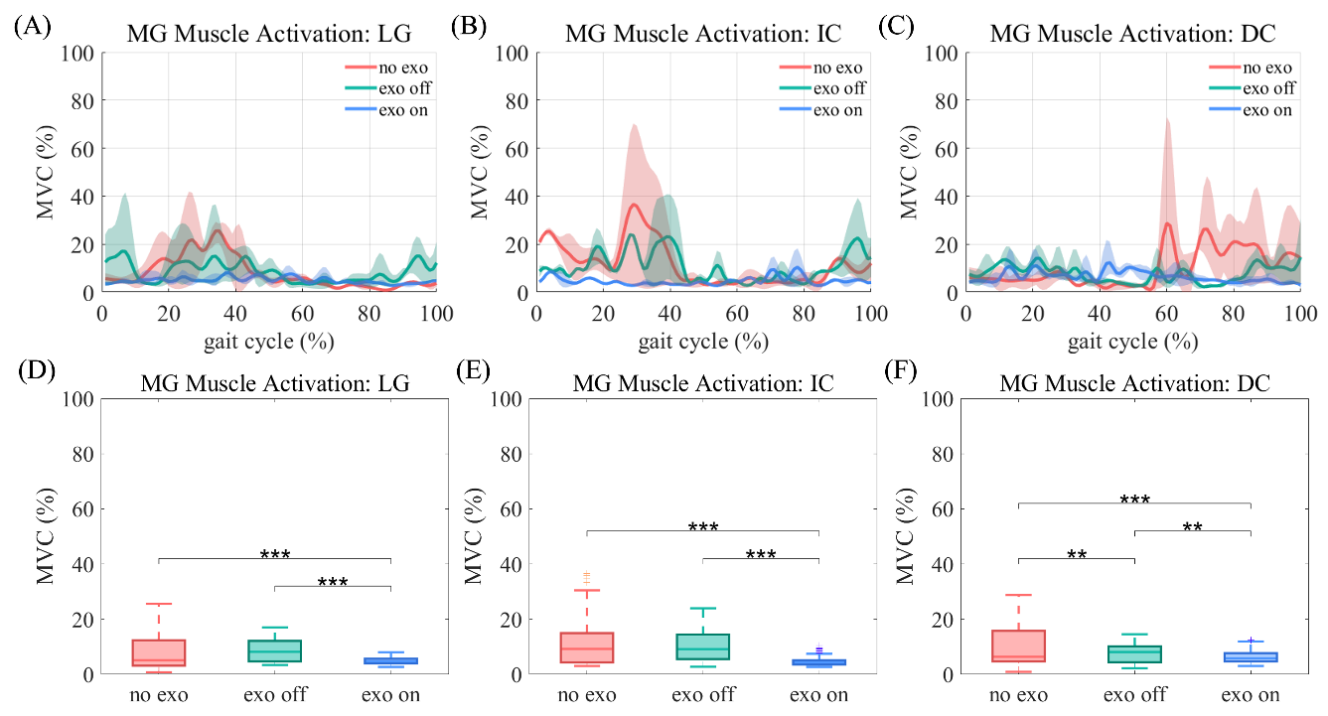

4) We would like to note that there were instances in the manuscript where the first letters of subsection titles were not capitalized appropriately.

Action: We have meticulously reviewed these sections and made the necessary corrections to ensure that all subsection titles conform to the required formatting standards.

“3.1. Data Acquisition and Class Definition”
“3.2. YOLO Model Training”
“3.3. LSTM-based Spatio-temporal Feature Extraction”
“5.1. Real-time Environment Classification Performance”

5) We have observed that the labels for the x-axis and y-axis, as well as the legends and titles within the figures, were not displayed appropriately, which could potentially hinder the readability for users.

Action: To address this concern, we have adjusted the font sizes of the x-axis, y-axis, legends, and titles in several figures. Additionally, we have standardized the sizes of the graphs to enhance overall clarity and accessibility.

- Figure 5. Evaluation metrics for real-time gait environment classification vision system
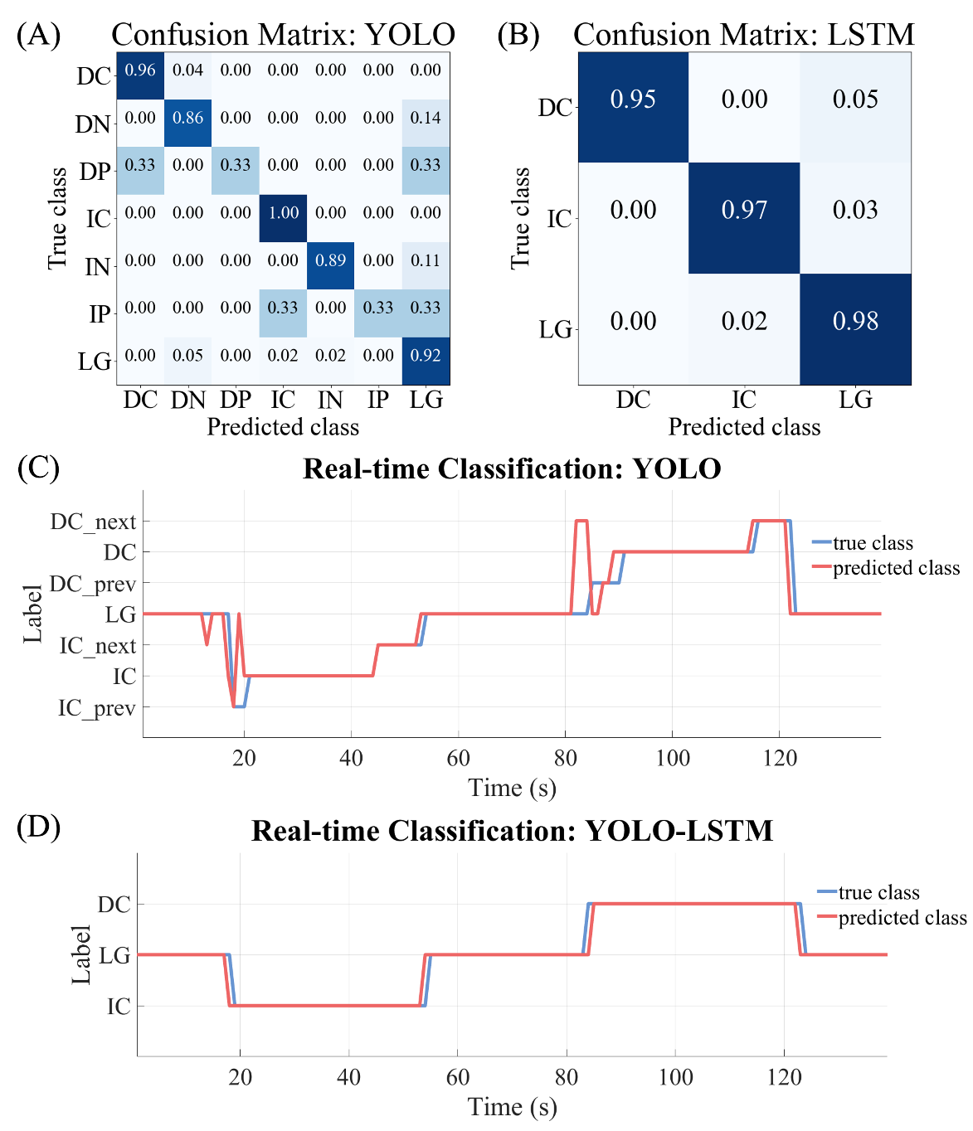

- Figure 7. TA muscle activation across the gait cycle for each gait environment.
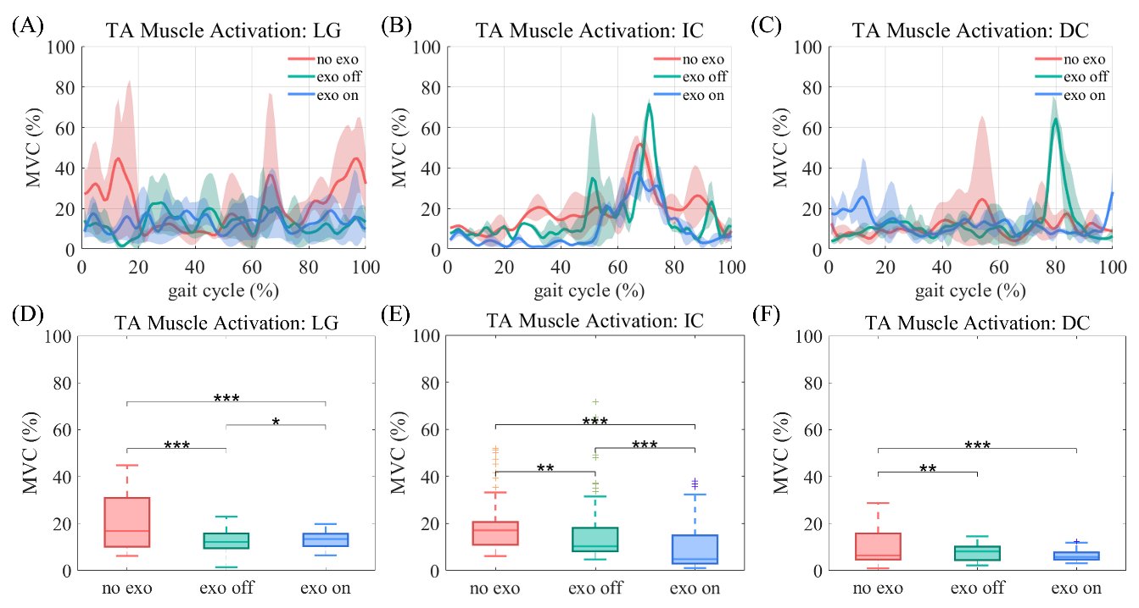

- Figure 8. MG muscle activation across the gait cycle for each gait condition.
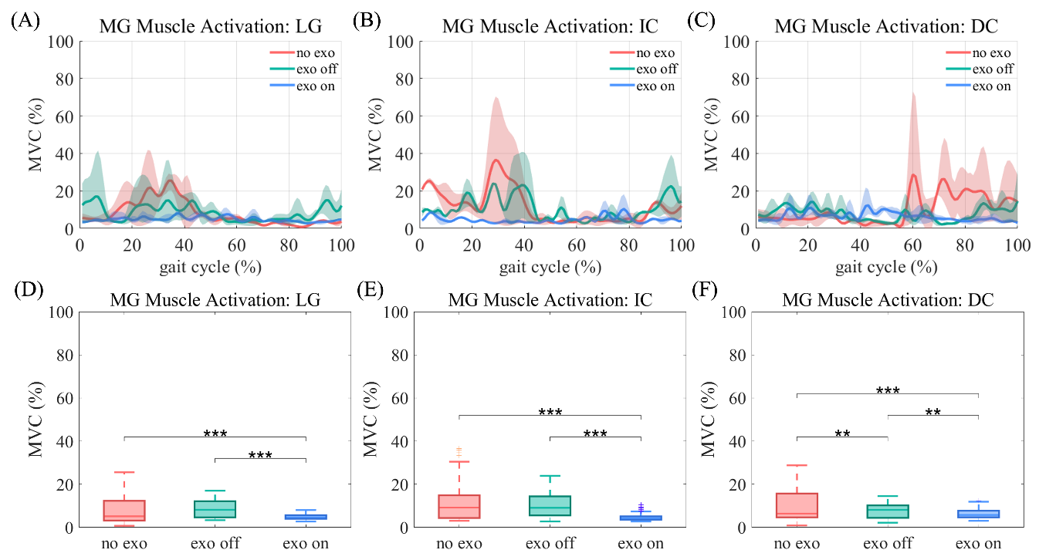

Reviewer: 2
Comments to the Author:
The research developed an intelligent vision-based classification system to enhance the adaptability of a soft ankle exosuit for stroke patients, particularly during stair negotiation. It utilized spatio-temporal feature extraction techniques, integrating YOLO for environment segmentation and LSTM for accurate transition detection, significantly improving the suit's ability to adapt to changes in the walking environment. Here are my comments:
1) What theoretical contributions does your work make to the fields of robotics and rehabilitation?
Response: We appreciate the reviewer’s insightful comment regarding the theoretical contributions of our work. In the revised conclusion, we have addressed how our study advances the theoretical frameworks within the fields of robotics and rehabilitation by highlighting the innovative integration of YOLO and LSTM technologies in adaptive exoskeleton design. This can be found in final paragraph of ‘7. Conclusion’ section. We have addressed how our findings pave the way for further exploration in robotic rehabilitation, specifically focusing on the optimizing user-specific interventions. We believe this clarification strengthens the theoretical foundation of our study and aligns with the broader objectives of advancing rehabilitation technologies.

Action: The modification has been made in the manuscript as follows:

- 7. Conclusion (Paragraph 3)
“This approach establishes a framework for future developments in robotic rehabilitation technologies, emphasizing the importance of real-time environmental awareness in improving user outcomes. It advances the understanding of adaptive exoskeleton design through the integration of YOLO’s object classification capabilities with LSTM’s temporal pattern recognition. Furthermore, by demonstrating the effects of the exosuit on ankle dorsiflexion and muscle activation during various gait scenarios, this work provides new insights into advancing robotic interventions for stroke patients, thereby informing future designs and applications in therapeutic robotics.”

2) The use of a single subject for the study's validation is a limitation. The system’s effectiveness and adaptability across different individuals with varying levels of stroke severity and motor capability are not demonstrated.
Response: Thank you so much for your insightful comments. We fully understand and agree with the reviewer’s suggestion regarding the importance of validation with a diverse cohort of participants. However, we would respectfully like to clarify that the main aim of this paper is to validate the feasibility of the proposed methodology, rather than conducting extensive validation across multiple subjects at this stage. As our research is intended to validate the feasibility of the system, a larger-scale validation involving stroke patients will require collaboration with medical professionals, which is beyond the scope of the current study.
We fully agree that future work should include experiments involving a larger and more diverse cohort of participants, and we plan to conduct such studies in collaboration with medical professionals. This will allow us to evaluate the system’s performance across different clinical profiles and validate its adaptability and effectiveness in real-world scenarios. In response to your feedback, we have updated the manuscript accordingly in ‘6. Discussion’ section. We sincerely thank you for emphasizing this important aspect, which will strengthen the robustness of our future findings.

Action: The modification has been made as follows:

- 6. Discussion (Paragraph 5)
“… Moreover, future studies should incorporate trials involving a diverse cohort of subjects, particularly stroke patients exhibiting foot drop symptoms and characterized by varying levels of stroke severity and motor capabilities to validate the effectiveness of the exosuit in real-world scenarios.”

3) Details on the complexity and variability of the environments where the experiments were conducted (e.g., indoor vs. outdoor, lighting conditions, types of stairs) need be added.
Response: Thank you for your valuable feedback regarding the needs for more details of the environments in which our experiments were conducted. We appreciate the importance of this context for understanding the robustness of our proposed system and included the requested details in the ‘4. Experiment’ section. The experiments were conducted in an illuminated indoor environment within a building, specifically utilizing straight stairs with a tread depth of 28 cm and a rise height of 16 cm. This controlled setting allowed for consistent lighting conditions and stair dimensions, facilitating a focused assessment of the exosuit's performance.
Action: The modification has been made in the manuscript as follows:

- 4. Experiment (Paragraph 1)
“… The experiments were conducted in an indoor environment within a building, utilizing straight stairs with a tread depth of 28 cm and a rise height of 16 cm. The experimental setup was characterized by uniform lighting conditions, unaffected by sunlight, and featured a tread width 1.2 m, ensuring that both edges of the staircase were captured by the camera. …”

4) This paper lacks a recent related deep learning advancements, like Predictive modeling of flexible EHD pumps using KAN; and Large language models for human-robot interaction: A review.
Response: We are grateful for the insightful feedback and comments, which helped us enhance the quality of the manuscript. In response, we conduct a review of the latest literature and integrate findings on deep learning methodologies in the ‘1. Introduction’ section. We highlight specific advancements, such as Large Language Model, Kolmogorov-Arnold Networks and Yolo v8 that have emerged in the past few years. We ensure to include citations of these recent studies to provide a comprehensive overview of the current landscape in deep leaning as it pertains to our research. Thank you for your valuable input.
Action: The modifications have been made in the manuscript as follows:

- 1. Introduction (Paragraph 5)
“To enhance the overall performance of the vision system, the deep learning-based methodologies can be employed. Recent advancements in deep learning model have significantly influenced diverse fields, including robotics such as robot control and intention detection, leading to enhanced performance and novel methodologies [*]. Large Language Model (LLM) have revolutionized natural language processing by advancing capabilities in text generation, high-level reasoning, and multimodal tasks, thereby transforming human-robot interaction across various domains [*]. Additionally, Kolmogorov-Arnold Networks (KANs) present a novel approach by replacing conventional neural network weights with learnable activation, offering enhanced accuracy and mechanistic interpretability [*]. Furthermore, YOLOv8 represents a significant advancement in the domain of real-time object detection, enhancing both computational speed and accuracy, thereby proving effective for applications in video analysis and environment classification [*]. Nevertheless, the integration of deep learning-based environment classification into assistive robotics applications remains underexplored, despite the significant advancements in the field.”
*Reference [29 - 33] in the manuscript

5) The manuscript focuses primarily on classification accuracy and lacks other critical performance metrics such as precision, recall, specificity, and F1-score for each class detected by the system.
Response: We would like to thank the reviewer for highlighting the importance of additional performance metrics. In response to the reviewer’s comment, we have incorporated explanation about the metrics such as precision, recall, and F1-score for each class in ‘5.1. Real-time Environment Classification Performance’ subsection of ‘5. Results’ section and first and second paragraph of ‘6. Discussion’ section. This enhancement provides a more comprehensive evaluation of the model’s performance, allowing for a clearer understanding of limitation across different classes. We believe these additions will improve the overall quality of the manuscript.

Action: The modifications have been made in the manuscript as follows:

- 5. Results – 5.1. Real-time Environment Classification Performance (Paragraph 2, 3)
“The real-time performance evaluation metrics of the YOLO system identified instances of misclassification and the overall F1score for the class is below 0.96. Particularly, the system exhibited a significant lower accuracy during the initial transition from level ground to a stair environment. Particularly, the precision values in the IC_prev and DC_prev is 1, while the recall value is notably low at 0.333. indicating a significant imbalance. Consequently, the F1 score was 0.500, reflecting this deficiency. Additionally, in the DC_ next class, the precision, recall value and F1 score were 0.600, 0.857 and 0.706 respectively, indicating a relatively low performance.
Conversely, the confusion matrix for the YOLO-LSTM system demonstrated high accuracy for incline and decline environments, with a reduction in misclassifications. This vision system enhanced performance, as demonstrated by the improved precision, recall, F1 scores and accuracy for LG, IC, and DC, relative to YOLO alone. Particularly, the F1 score of overall class exceeds 0.96, indicating a balance classification performance across the various class.”

- 6. Discussion (Paragraph 1, 2)
“… In the initial transition from the level ground to a stair environment, the system utilizing YOLO alone displayed a notably low recall value and high precision value, indicating system failed to identify a significant portion of actual instances within these classes, leading to a substantial imbalance in performance. In contrast, the DC_next class with a low precision value, suggests that while the system effectively identifies actual instances, it also incurs a substantial number of incorrect predictions.
The YOLO-LSTM vision system offers substantial improvements over the YOLO alone, particularly in decline environments. The improved precision, recall, and F1 scores for each class validate the effectiveness of the YOLO - LSTM approach in addressing the complexities of real-gait analysis. Overall, this indicates the system effectively identify actual instances while minimizing the misclassification, reflecting the reliable and robust performance. …”

6) Confidence intervals and p-values should be included to demonstrate the statistical significance of the results.
Response: We appreciate the reviewer’s recommendation to include confidence intervals and p-values to demonstrate the statistical significance of our results. We have revised the ‘Muscle Reduction’ subsections of the ‘5. Results’ section to clearly present confidence intervals and p-values, providing a comprehensive understanding of the significance of our findings.
Additionally, we have elaborated on the results with low statistical significance in the ‘6. Discussion’ section, indicating that this may be attributed to the experiments being conducted in a limited environment with a single participant. Consequently, future work will necessitate conducting studies in diverse environments with multiple subjects to enhance the robustness and generalizability of our findings.

Action: The modifications have been made in the manuscript as follows:

- 5. Results – 5.3. Muscle Reduction
“… A paired t-test revealed a significant reduction in activation between the overall conditions: no exo vs exo off (p < 0.001, 95% CI = 6.08, 11.05), no exo vs exo on (p < 0.001, 95% CI = -9.79, -5.03), and exo off vs exo on (p = 0.04, 95% CI = -2.34, 0.03). This indicates a similar reduction of 7.86 ± 13.98% in the exo off condition and 7.41 ± 11.89% in the exo on condition compared to the no exo condition.
In the stair incline environment, TA muscle activation indicated a significant reduction across the overall conditions: no exo vs exo off (p = 0.002, 95% CI = 0.02, 6.40), no exo vs exo on (p < 0.001, 95% CI = 2.23, 8.66), and exo off vs exo on (p < 0.001, 95% CI = -11.45, -5.86). Particularly, it decreased by 3.21 ± 9.92% and 8.65 ± 7.07% in the exo off (15.24 ± 12.77%) and exo on (9.79 ± 10.12%) conditions, respectively, compared to the no exo condition (18.44 ± 9.92%).
In the stair decline environment, TA muscle activation showed similar values across the no exo (10.75 ± 4.25%), exo off (12.34 ± 10.93%), and exo on (12.09 ± 4.81%) conditions, with slight increases of 1.59 ± 11.19% and 1.34 ± 7.10% in the exo off and exo on conditions respectively compared to no exo condition (p = 0.007, 95% CI = -5.06, -0.62, p < 0.001, 95% CI = 1.81, 3.98).
However, no statistically significant differences were observed between the exo off and exo on conditions (p = 0.97, 95% CI = -2.39, 2.28).
For the MG muscle, which is activated during plantarflexion, a significant reduction was observed in the level ground environment with a decrease of 3.01 ± 6.16% and 3.64 ± 4.27% respectively in the exo on condition compared to the no exo condition (p < 0.001, 95% CI = -4.33, -1.68) and exo off condition ( p < 0.001, 95% CI = 2.81, 4.47) as illustrated in Figure 8 (no exo: 7.88 ± 6.61%, exo off: 8.51 ± 4.04%, exo on : 4.87 ± 1.21%). There was no statistically significant difference observed between no exo and exo off condition (p = 0.31, 95% CI = -2.16, 0.90).
Similarly, in the stair incline environment, MG muscle activation decreased by 7.01 ± 9.70% and 5.96 ± 6.80% in the exo on conditions compared to unworn exosuit condition (p < 0.001, 95% CI = -8.79, -5.24) and worn-but-unpowered exosuit condition (p < 0.001, 95% CI = -4.73, 7.19), respectively (no exo: 11.71 ± 8.83%, exo off: 10.66 ± 5.99%, exo on : 4.70 ± 1.69%). The EMG reduction observed between no exo and exo off conditions was not statistically significant (p = 0.15, 95% CI = -1.05, 3.16).
In the stair decline environment, muscle reduction of 2.35 ± 6.49% and 3.57 ± 4.51% was observed in the exo off and exo on conditions, respectively (no exo: 9.97 ± 7.35%, exo off: 7.62 ± 3.41%, exo on: 6.41 ± 2.19%). The results in decline environment were statistically significant between the overall conditions: no exo vs exo off (p = 0.006, 95% CI = 0.75, 3.95), no exo vs exo on (p < 0.001, 95% CI = -5.08, -2.06), and exo off vs exo on (p = 0.04, 95% CI = -2.34, 0.03).”

- 6. Discussion (Paragraph 4)
“…The statistical analysis revealed that the TA muscle exhibited low statistical significance between the exo off and exo on conditions during stair descent. Similarly, the MG muscle demonstrated low statistical significance between the no exo and exo off conditions on level ground and during stair ascent. These findings can be attributed to the experimental constraints, as the study was conducted in a limited environmental condition with a single participant, potentially contributing to the reduced significance in certain conditions. However, the TA muscle demonstrated high statistical significance between the no exo and exo on conditions during stair descent, indicating a reliable reduction in muscle activation due to the exosuit. Moreover, the MG muscle displayed high statistical significance between the exo on and exo off conditions, further validating the performance of the exosuit.”

7) Can you detail the process through which environmental classifications from YOLO influence the LSTM’s spatio-temporal predictions?
Response: Thanks you so much for your comments. We have explained the influence of environmental classifications from the YOLO framework on the LSTM’s spatio-temporal predictions in ‘3. Environment Recognition System’ section. The YOLO system performs real-time analysis of video frames, classifying the gait environment into conditions such as level ground, early stair, mid stair, and late stair. These classifications provide crucial contextual information for the LSTM, allowing it to understand transitions across environments. The classification outputs are organized into sequences that reflect the temporal progression of the gait environment. By annotating each frame with its corresponding classification, the LSTM can effectively extract relevant features for each stage of stair negotiation. This enhanced contextual understanding improves its predictive capability for transitions and enhances overall classification accuracy between level ground and stair conditions.
Action: The modifications have been made in the manuscript as follows:

- 3. Environment Recognition System – 3.3 LSTM-based Spatio-temporal Feature Extraction (Paragraph 3)
“Figure 3 illustrates overall vision systems for gait environment classification. YOLO framework performs real-time analysis of each video frames, classifying the environment into distinct environment conditions, such as level ground, early stair, mid stair, and late stair. This environmental classification provides crucial contextual information for the LSTM, facilitating its understanding of transitions across diverse environments. This classification outputs are subsequently organized into sequences that reflect the temporal progression of gait environment. Each frame within these sequences is annotated with its corresponding environmental classification, thereby preserving temporal feature for the LSTM's analysis. By providing subdivided context regarding the current gait environment through YOLO output, the LSTM effectively extract relevant features corresponding to each phase of stair negotiation, improving its predictive capability for environment transitions and enhancing the overall classification accuracy between level ground and stair condition.”

Additional revisions:
In addition to addressing the reviewers' comments, we have made several further modifications to enhance the clarity and overall quality of the manuscript. These changes, although not specifically highlighted by the reviewers, include the correction of typographical errors, spacing issues, and grammatical mistakes; the revision of the EMG signal graphs for the TA and MG muscles; adjustments to the formatting of subsection titles; and improvements in the visibility of figure labels, legends, and titles. We believe these revisions contribute positively to the manuscript and provide a clearer understanding of our findings.

1) We acknowledge that there are typographical errors, spacing issues and grammatical mistakes present in the manuscript.

Action: All noted typographical errors, spacing issues and grammatical errors have been corrected, and we have ensured that the manuscript now adheres to the required standards of accuracy.

“The label value of the walking environment, denoted as vision data k, defined as Equation(1), is subsequently transmitted to Simulink via user datagram protocol (UDP) communication.”
“The MotorInputData processed according to Equation (3) informs motor input parameters, derived from the shank angular velocity w_s and thigh angular velocity w_t, outlined in Equation (2).”
“YOLO algorithm is an object detection framework widely utilized in various computer vision fields [*].”
“LSTM is a recurrent neural network (RNN) designed to train long-term dependencies in sequential data and demonstrates superior performance by overcoming the vanishing and exploding gradient problems inherent in traditional RNN [*]”
“Surface electromyography (sEMG) sensors (LAXTHA Inc., South Korea). were employed to measure muscle activation during gait in each experimental condition.”
“Figure 5. (d) Integrated vision system-based environment classification results over time”
“The results of TA muscle activation for each gait environment are presented in Figure 7.”
“Furthermore, similar ankle angles are observed whether the exosuit is in an unpowered or powered state.”
*Reference [46, 48] in the manuscript

2) During the review of the manuscript, we identified an error where the prediction values and true value data were reversed in the YOLO-LSTM graph and evaluation metrics. We sincerely regret this oversight that occurred during the processing of the original graphs. To prevent such errors in the future, we meticulously re-evaluated the data within the manuscript to ensure accuracy.

Action: We recalculated and updated the precision, recall, F1 score, and accuracy values in Table 2. Additionally, we have revised the confusion matrix and environment classification results over time in Figures 5(b) and (d). However, we would like to emphasize that the conclusion regarding improved performance compared to the YOLO system remains unchanged, with only the values in the graph being adjusted.

- Table 2. Environment Classification Performance


- Figure 5. Evaluation metrics for real-time gait environment classification vision system
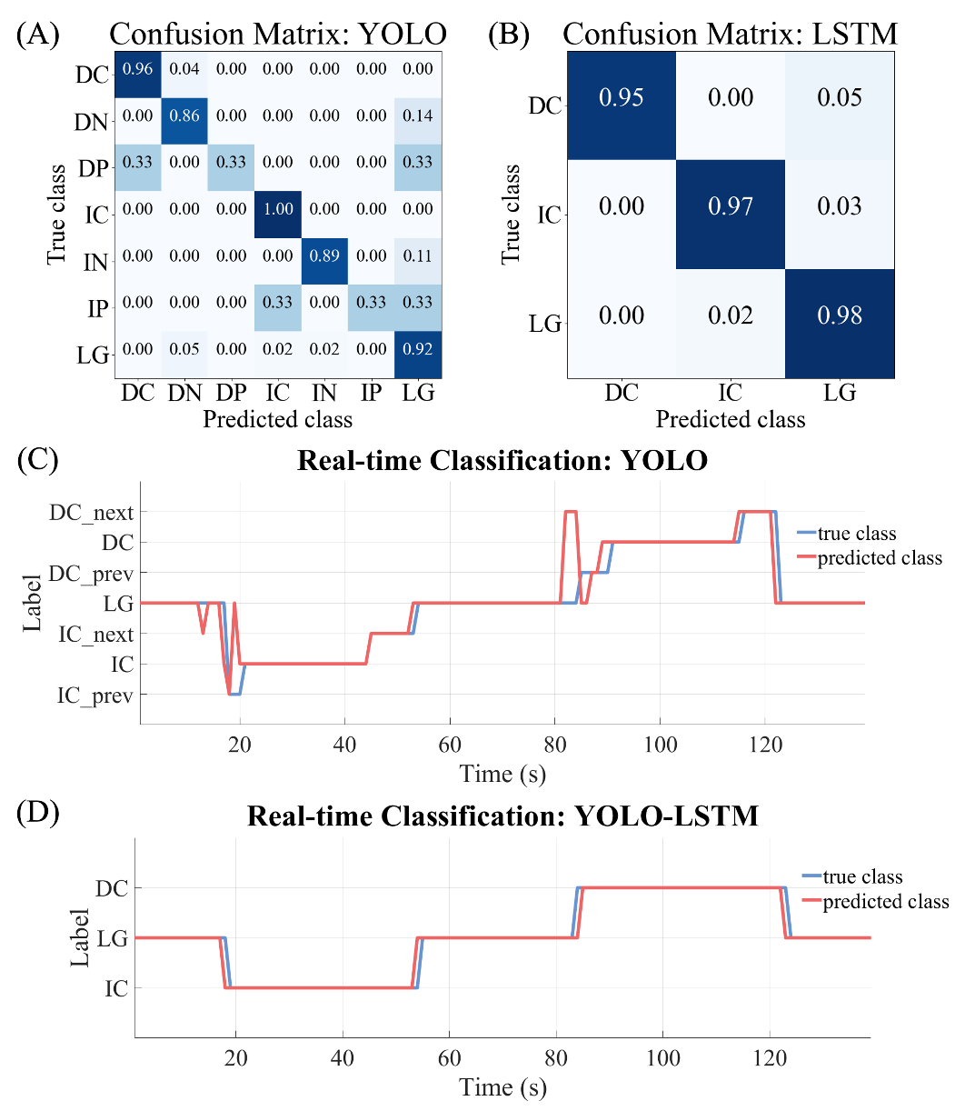

3) We have identified that the graphs representing the EMG signals for the TA and MG muscles were recorded in reverse within the corresponding graph. Furthermore, we noticed discrepancies in the p-values and asterisks between the no exo and exo off conditions, as well as between the exo off and exo on conditions for the TA muscle during the stair decline environment.

Action: In response, we undertook a thorough review of the graph positions and indices, resulting in the necessary corrections to ensure accurate representation. We have taken care to rectify the asterisks to align correctly with the calculated p-values. We appreciate your understanding as we strive to enhance the quality of our work.

- Figure 7. TA muscle activation across the gait cycle for each gait environment.


- Figure 8. MG muscle activation across the gait cycle for each gait condition.
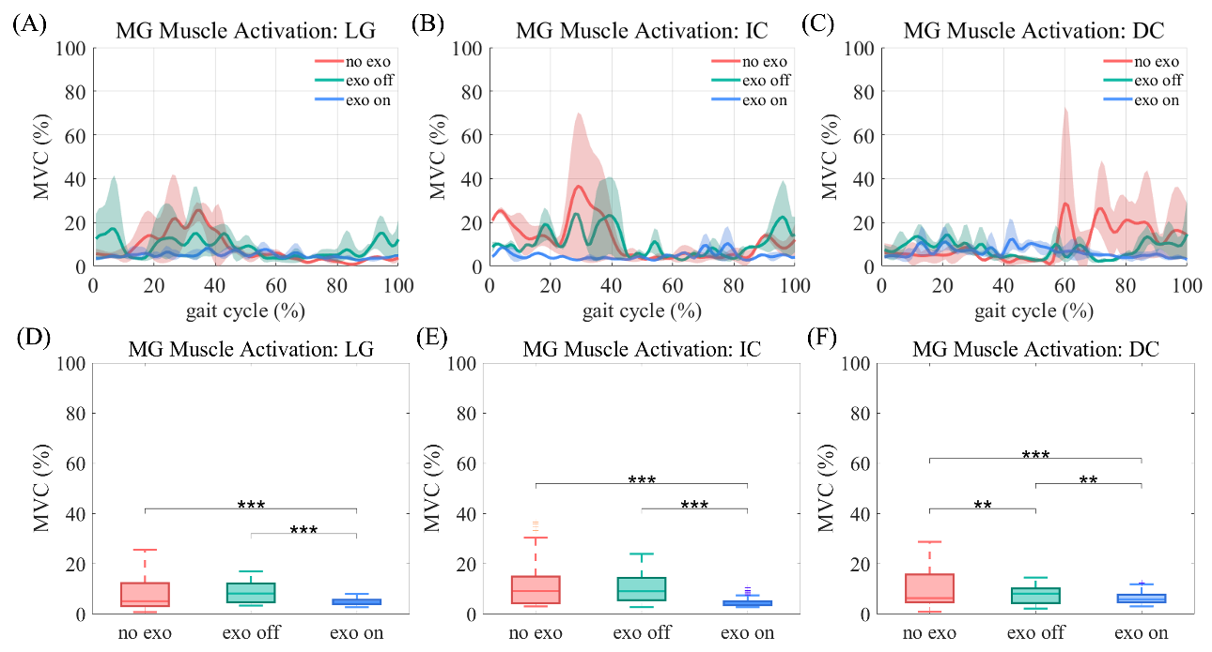

4) We would like to note that there were instances in the manuscript where the first letters of subsection titles were not capitalized appropriately.

Action: We have meticulously reviewed these sections and made the necessary corrections to ensure that all subsection titles conform to the required formatting standards.

“3.1. Data Acquisition and Class Definition”
“3.2. YOLO Model Training”
“3.3. LSTM-based Spatio-temporal Feature Extraction”
“5.1. Real-time Environment Classification Performance”

5) We have observed that the labels for the x-axis and y-axis, as well as the legends and titles within the figures, were not displayed appropriately, which could potentially hinder the readability for users.

Action: To address this concern, we have adjusted the font sizes of the x-axis, y-axis, legends, and titles in several figures. Additionally, we have standardized the sizes of the graphs to enhance overall clarity and accessibility.

- Figure 5. Evaluation metrics for real-time gait environment classification vision system
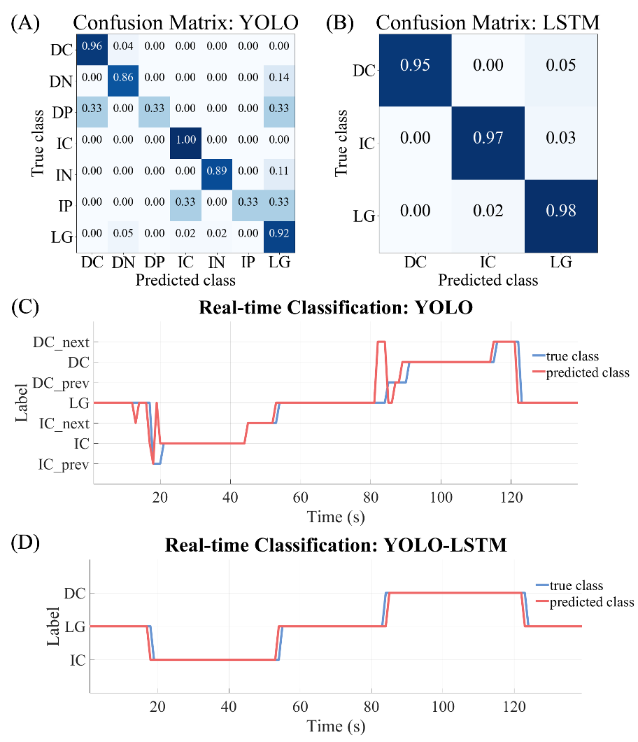

- Figure 7. TA muscle activation across the gait cycle for each gait environment.


- Figure 8. MG muscle activation across the gait cycle for each gait condition.


